 | Greater Texas Chapter Newsletter
October 30, 2013
In This Issue  - President’s Message  - Profiles on Greater Texas chapter board members: Leigha Eldridge, Cathy Lux, and Rebecca Sherman  - Reminder about Senate Bill 406  - National Nurse Practitioner Week  - Recap of 2013 Greater Texas chapter conference  2013-2014 Officers  President  Erica Flores  President-Elect  Kim McHard  Past President/By-Laws  Robin Henson  Secretary  Lindy Moake  Treasurer  Mehreen Lakhani  Membership  Leigha Eldridge  Public Relations  Rebecca Sherman  Continuing Education Co-chair, Dallas  Sharolyn Dihigo  Technology  Cathy Lux  Nominations & Student Liaison  Madeline Broemsen  Legislative  Kristin Hittle  UTA Student Rep  Ashlee House  Upcoming Chapter Events  - SAVE THE DATE: The next business dinner meeting will be at 6:30 p.m. Nov. 20 at Cool River in Irving.  - The chapter’s Holiday Happy Hour will be held at 6 p.m. Wed., Dec. 4 at Cyclone Anaya’s in Dallas.  Chapter Treasurer Report  Cash on hand  Income:  - Membership dues: $2,795.00  Expenses: $15.44  Budget balance: $2,779.56  Conference:  - Conference profit: $9,341.00  Contact us  E-mails for board members are at:  http://community.napnap.org/TX  Greater/Home | President’s Message  This year, you will learn more about how wonderful these women are and what a vital role they play in our chapter as we have decided to highlight them in our newsletter  In July, the board collaborated, planned and created new goals for 2013-2014. We used last year’s goals as a foundation as well as valuable recommendations from our member and board member surveys to formulate our new goals to maintain our mission: “To empower pediatric nurse practitioners (PNPs) and their healthcare partners to enhance child and family health through practice, leadership, advocacy, education and research.”  “To provide a network of advanced practice nurses…” by increasing communication and transparency as a board and members through the following efforts:  - providing nametags at each meeting;  - adding our board and general meeting minutes on our website in a timely manner;  - encouraging and empowering members to meet someone new and or more experienced as a nurse practitioner and NAPNAP member;  - encouraging members to exchange business cards and contact information;  - promoting board and member awareness through our newsletter and annual awards;  - increasing our connectivity through our webpage, newsletter, Facebook, Skype, Face time, networking socials, membership surveys and the formation of special committees.  “To develop and/or sponsor educational programs…” by continuing to offer educational bi-monthly general meetings, participating in local and national conferences and encouraging members to become involved in our local conference committee and serving as speakers.  “To provide support and facilitate state and local programs…” by maintaining financial support for CNAP, encouraging members to physically participate in Legislative Day by planning a Greater Texas Chapter road trip to Austin and by utilizing our website and Facebook page to increase legislative literacy and advocacy by educating members about legislative issues that impact nurse practitioners. We also plan on continuing to support community outreach and philanthropic programs.  “To coordinate with other professional organizations…” by sponsoring student representatives from TWU and UTA PNP programs annually, continuing to support and promote local university NP and DNP programs, and implementing our Lisa Milonovich Nursing scholarships.  Our newsletter and membership emails will expand more on our progress throughout the year. I also would like to take this opportunity to thank you for your time, commitment and dedication to NAPNAP and to the health and well-being of our children and families as a pediatric nurse practitioner. I’d like to invite you to participate in NAPNAP as members. We encourage your suggestions because your input is valuable to our growth and progress as we strive toward our goals and mission. Please feel free to contact me at ericalouise@gmail.com.  Sincerely,  Erica Flores RN, MSN, CPNP-PC, CPNP-AC  Board member profile: Leigha Eldridge  As a member of the pediatric surgery team, Leigha has focused her efforts on acquiring a greater understanding of surgical procedures in an effort to develop her own level of autonomy as a nurse practitioner while simultaneously working at the bedside with patients and families to make life better for children.  Through her volunteer work with her local NAPNAP chapter, Leigha has been able to connect with medical professionals locally and nationally, which has expanded her peer network and provided new resource avenues for NAPNAP fundraisers and conferences. The connections and skills gained through NAPNAP have made it a vital resource to her development as a nurse practitioner.  Leigha enjoys trying to keep up with her two children and counting the days until they get along.  Board member profile: Cathy Lux  Board member profile: Rebecca Sherman  Rebecca is a pediatric nurse practitioner with the Center for Cancer and Blood Disorders at Children’s Medical Center, where she has worked for two years. She has been a member of the Greater Texas NAPNAP chapter for about three years. She joined the organization when she was a nurse practitioner student in her final semesters of grad school.  Rebecca started her career with an ADN in June 2003 from Collin College in McKinney, Texas. She completed her bridge to a BSN in December 2007 from the University of Texas at Arlington. She completed her MSN with dual certification as a primary and acute care Pediatric Nurse Practitioner in December 2011.  “I enjoy working closely with patients and their families,” she said.” I focus on educating them about their healthcare while they are navigating through such a difficult disease process.”  Rebecca is the chapter public relations chair, the first board position she has held with the organization.  I think it is important to be involved in the local NAPNAP chapter for networking purposes with other colleagues from different specialties,” she said. “I feel we all have so much to teach each other. I also think it is important to be involved in the local NAPNAP chapter as a way to go into the community to serve and educate the population.”  Chapter kicks off 2013-14 year  More than 40 NAPNAP members attended the first meeting of the year on July 20. The new board members were introduced at the meeting.  Dr. Benjamin D. Gold presented a lecture entitled, “Protein Choices and Allergy Risk in Early Infant Feeding.” Dr. Gold works in the Pediatric Gastroenterology, Hepatology and Nutrition area at Children’s Center for Digestive Healthcare.  Dr. Gold's presentation was both educational and entertaining. Many thanks to Dr. Gold and Donna Burg with Nestle Infant Nutrition for generously supporting the Greater Texas Chapter of NAPNAP.  Implementation of SB 406 is Nov. 1, 2013  S.B. 406 has passed and been signed into law by Governor Perry. The key components of the bill are:  1. Eliminates the current site-based requirements and replaces them with a standardized prescriptive authority agreement that requires practitioners (physicians, advanced practice registered nurses and/or physician assistants) to develop and sign an agreement that is best for their practice as a professional team. ·  2. Increases from four to seven the number of individuals to whom a physician may delegate prescriptive authority at all other practice sites.  3. Allows hospital-based practices and practices serving medically underserved populations to remain unlimited in the number of APRNs and PAs to which a physician may delegate prescriptive authority.  4. Allows physicians to delegate prescriptive authority for Schedule IIs Controlled Substances to APRNs and PAs in hospitals and hospice.  5. Ensures that APRNs and PAs are treated the same as physicians in Medicaid and CHIP for the purposes of being assigned as primary care providers (PCPs).  6. Clarifies that the prescribing of durable medical equipment is reimbursable under Medicaid when prescribed by an APRN and PA.  Happy National Nurse Practitioner Week!  Since National Nurse Practitioner week is right around the corner, I’d like to take this opportunity to wish all of our members a Happy National Nurse Practitioner Week! Nurse practitioners across the country and the state in every specialty are commemorating November 10-16 as National Nurse Practitioner Week. In fact, Gov. Rick Perry has proclaimed this week as Nurse Practitioner Week in Texas. (see proclamation compliments of Texas Nurse Practitioner (TNP), http://www.texasnp.org/associations/8899/files/2013_Proclamation.pdf).  The Greater Texas Chapter of NAPNAP joins in this celebration by THANKING YOU for all the incredible hard work that you do every day! We are celebrating the accomplishments, achievements, and successes of all Nurse Practitioners and promoting awareness of the nation's more than 170,000 nurse practitioners, of which more than 9,000 practice in Texas by celebrating our members in our newsletter and becoming proactive in legislative issues that impact Nurse Practitioners by providing our members access to informative legislative education in our newsletter and website.  In addition, we’ll be participating in legislative visits locally and participating in CNAP meetings in Austin. This is a great opportunity to promote awareness of what nurse practitioners do in the community and it also provides us an opportunity to share how nurse practitioners are part of the solution to the health care system. Please contact Kristin at Kristin.Hittle@childrens.com if you are interested in taking part.  Lastly and once again, thank you Greater Texas Chapter Nurse Practitioners for your time, commitment and dedication to the health and well-being of our children! Have a great National Nurse Practitioner week everyone!  Sincerely,  Erica Flores RN, BSN, MSN, CPNP-PC, AC  President of Greater Texas Chapter of NAPNAP  Please feel free to contact me for any questions or concerns at ericalouise@gmail.com  Conference draws more than 100 participants  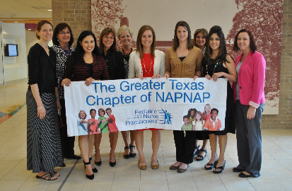  More than 100 pediatric nurse practitioners attended the first ever pharmacology-focused conference presented by the Greater Texas chapter at Texas Scottish Rite Children’s Hospital in Dallas in September.  The event covered the latest updates in pediatric clinical pharmacology. Greater Texas chapter board members, Robin Henson and Erica Flores, served as the co-chairs.  “We chose to have the conference focus on pharmacology because we wanted to make it less challenging for our peers to receive the pharmacology credit as part of their continuing education,” Flores said. “Our peers all come from different specialties but pharmacology is an area that we all have in common, and the pharmacology credit is one we all have to obtain.”  The event provided pediatric nurse practitioners, students and pediatric nurses with relevant, up-to-date, and pertinent information that was applicable for both out-patient and in-patient clinical settings, said Henson.  “It enabled our PNPs to obtain affordable pharmacology credit that could be applied to their license and certification renewals,” Henson said. “Those who attended were able to reunite and/or establish relationships with other PNPs that will continue on for many months and years to come. That is invaluable.”  Courtney Brewer, a registered nurse at Baylor Health Care System Emergency Care, and Lieutenant Jerry Rhodes, a retired Dallas police officer who worked in the narcotics division, served as the keynote speakers. Their session entitled, “R U Smarter Than a Junkie?,” covered substance use among children, adolescents and adults.  Additional conference presenters covered topics related to the management of pediatric headache and concussion, psychotropic medications in children and adolescents, and more. Flores said she believed the conference participants gained useful information from both a primary care and acute care perspective.  “For me personally, I practice in a pediatric orthopedic specialty, so naturally the vitamin D lecture and the arthritis presentation were most pertinent to my clinical practice,” Flores said. “With that said, I still enjoyed all of the pharmacology presentations that I was able to participate in.”  In addition to the presenters, 19 vendors participated in the conference. Overall, conference attendees enjoyed the conference. Some of the feedback from the attendees included: “Appropriate for primary care and acute care PNPs. Very helpful information!” and “Great opportunity to showcase our rich resources of medical professionals and reconnect with colleagues for networking and catching up!”  The conference committee members worked hard and spent much time planning the conference. Through teamwork, the committee members overcame some challenges such as juggling different parts simultaneously in order to present a well-organized, successful conference.  “At any given time we had frustrations with our venue, budget, brochure, web site, PayPal, speakers, poster presenters, and sponsors,” Henson said about the planning. “Fortunately, none were ever too overwhelming, and with the help of the Pharmville committee, they did not remain a frustration for long. A successful conference takes willing, dedicated, and tenacious team players!”  Henson summed up the conference with the following:  Price of Conference: $125  Number of Contact Hours: 8.75  Unanimous overwhelmingly satisfied attendees and participants: Priceless  More pictures from the conference  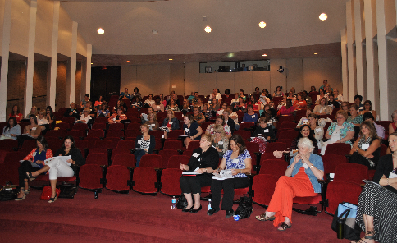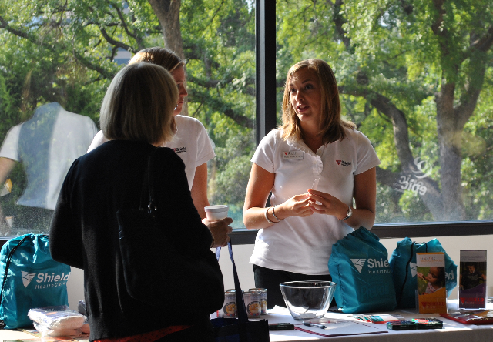
  Dear Greater Texas Chapter NAPNAP members,
  It was great to see many of you at our Pharmville Conference! It was our first ever pharmacology-focused conference, and it was successful thanks to your support and our hardworking conference committee!
  I’d like to take this opportunity to express what an honor and privilege it is to serve as your chapter president for 2013-2014. I’m dedicated and committed to continue to move our chapter forward by empowering our members and board.
  We’re fortunate enough to have such an amazing, hardworking, compassionate and active board of officers.
  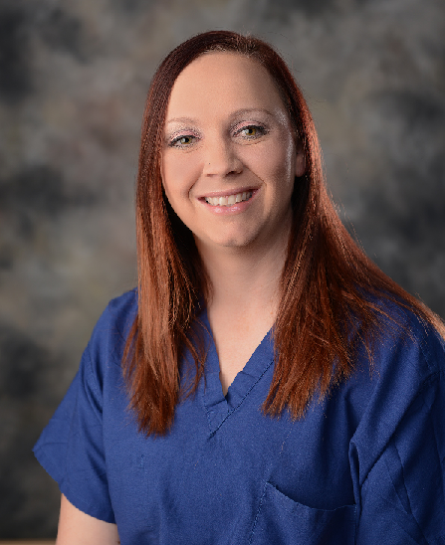 | Leigha Eldridge, Pediatric Nurse Practitioner, is a member of the Pediatric surgery service at Children’s Medical Center in Dallas. Leigha joined NAPNAP in 2011. In her time with NAPNAP, Leigha has had the honor of serving in various roles including the membership and nominations committees.  Leigha earned her Bachelor’s of Science in Nursing at The University of Texas in Austin in 2005 and her Master’s of Science in Nursing with a Post-Master’s Degree from The University of Texas in Arlington in 2010.  .
  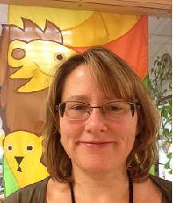 | Cathy Lux has been a PNP for over 19 years and a pediatric nurse for 26. She received her BSN, as well as a BA in Humanities/History, from John Hopkins, and her MSN from UTA. She is currently pursuing her DNP at UTA. She has worked in primary care at Parkland’s Oak West Clinic for 18 years. As an RN, she worked for several years in PICU.  Cathy has been a member of NAPNAP on and off for almost 20 years. The Technology chair is responsible for maintaining the Greater Texas NAPNAP webpage and Facebook page. She also mentors her son’s robotics club and co-coaches their teams in DISD.
  